**SNAP SHOES**

Built an IMS application for Snap Shoes, a company known for selling the latest shoe models from various reputed brands.

From a business perspective, IMS application plays a vital role for the company, the main goal being resource management and procurement.

The main business operation ideology revolves around some important aspects :

* SAVES MONEY: Inventory management allows a company to avoid this risk, ordering just enough to meet consumer demand – no more, no less.
* SATISFY CUSTOMERS:  Consistently running out of stock can lead to permanent customer losses and eventually an unprofitable business. Inventory management keeps a record of customer demand and turns this information into smart, efficient ordering.
* KEEPING THE WAREHOUSE ORGANISED:  Proper inventory management supports an organized warehouse, with carefully tracked inventory and supply chain movement.
* SAVES TIME: Keeping track of your products in real-time also saves you the time it takes to recount stock or check for record accuracy
* IMPROVE CASH FLOW: Smart inventory management, therefore, improves your cash flow, eliminating the need to spend large chunks of the budget all at once

Working of Java IMS application for Snap Shoes?

When the main home.java page runs the instances of objects for various classes are created in the backend while the form for the main class runs in on the frontend.

IDE USED:

* NetBeans IDE 11.2
* Java 8

OVERVIEW OF THE DIFFERENT FUNCTIONALITIES OF THE IMS APPLICATION:

Keeping in mind that the application should have a sleek and clean look, not only making it highly efficient for inventory management but also user-friendly to anyone trying to navigate through the system

1. The main Home page gives an overview of what the application is mainly trying to portray.

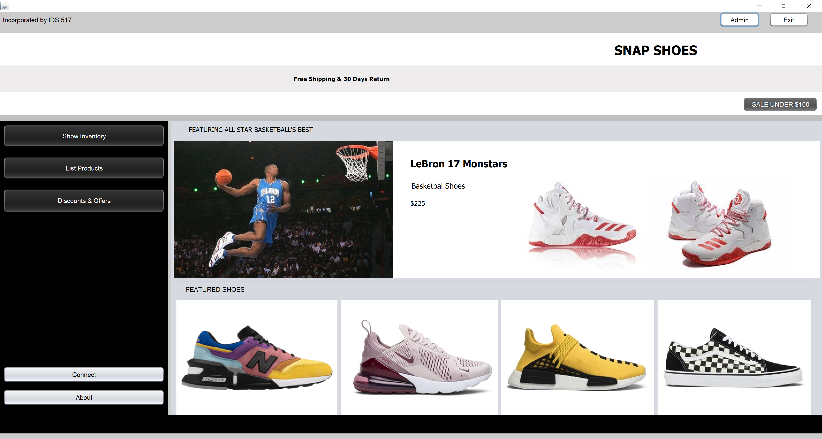

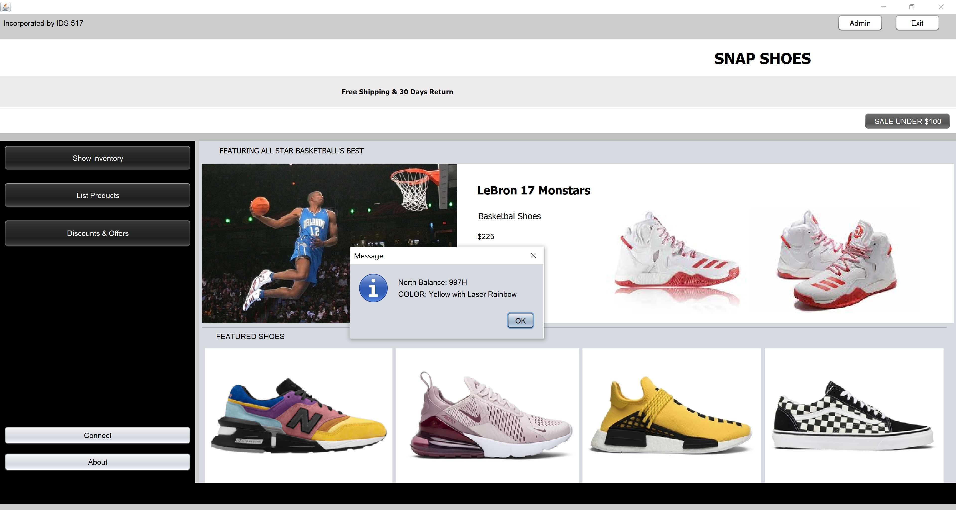

1. SHOW INVENTORY: This opens to the list of products available at present for consumer purchase.

Customer -

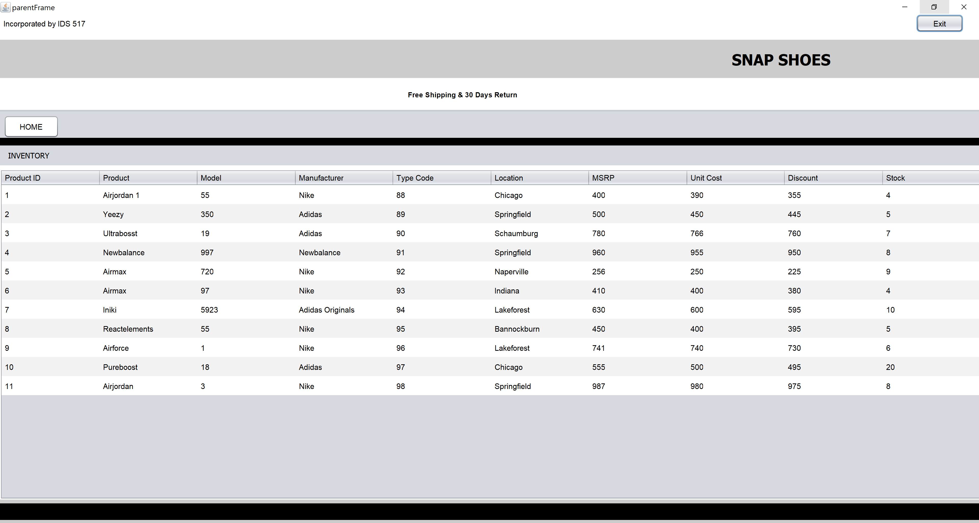

Admin –

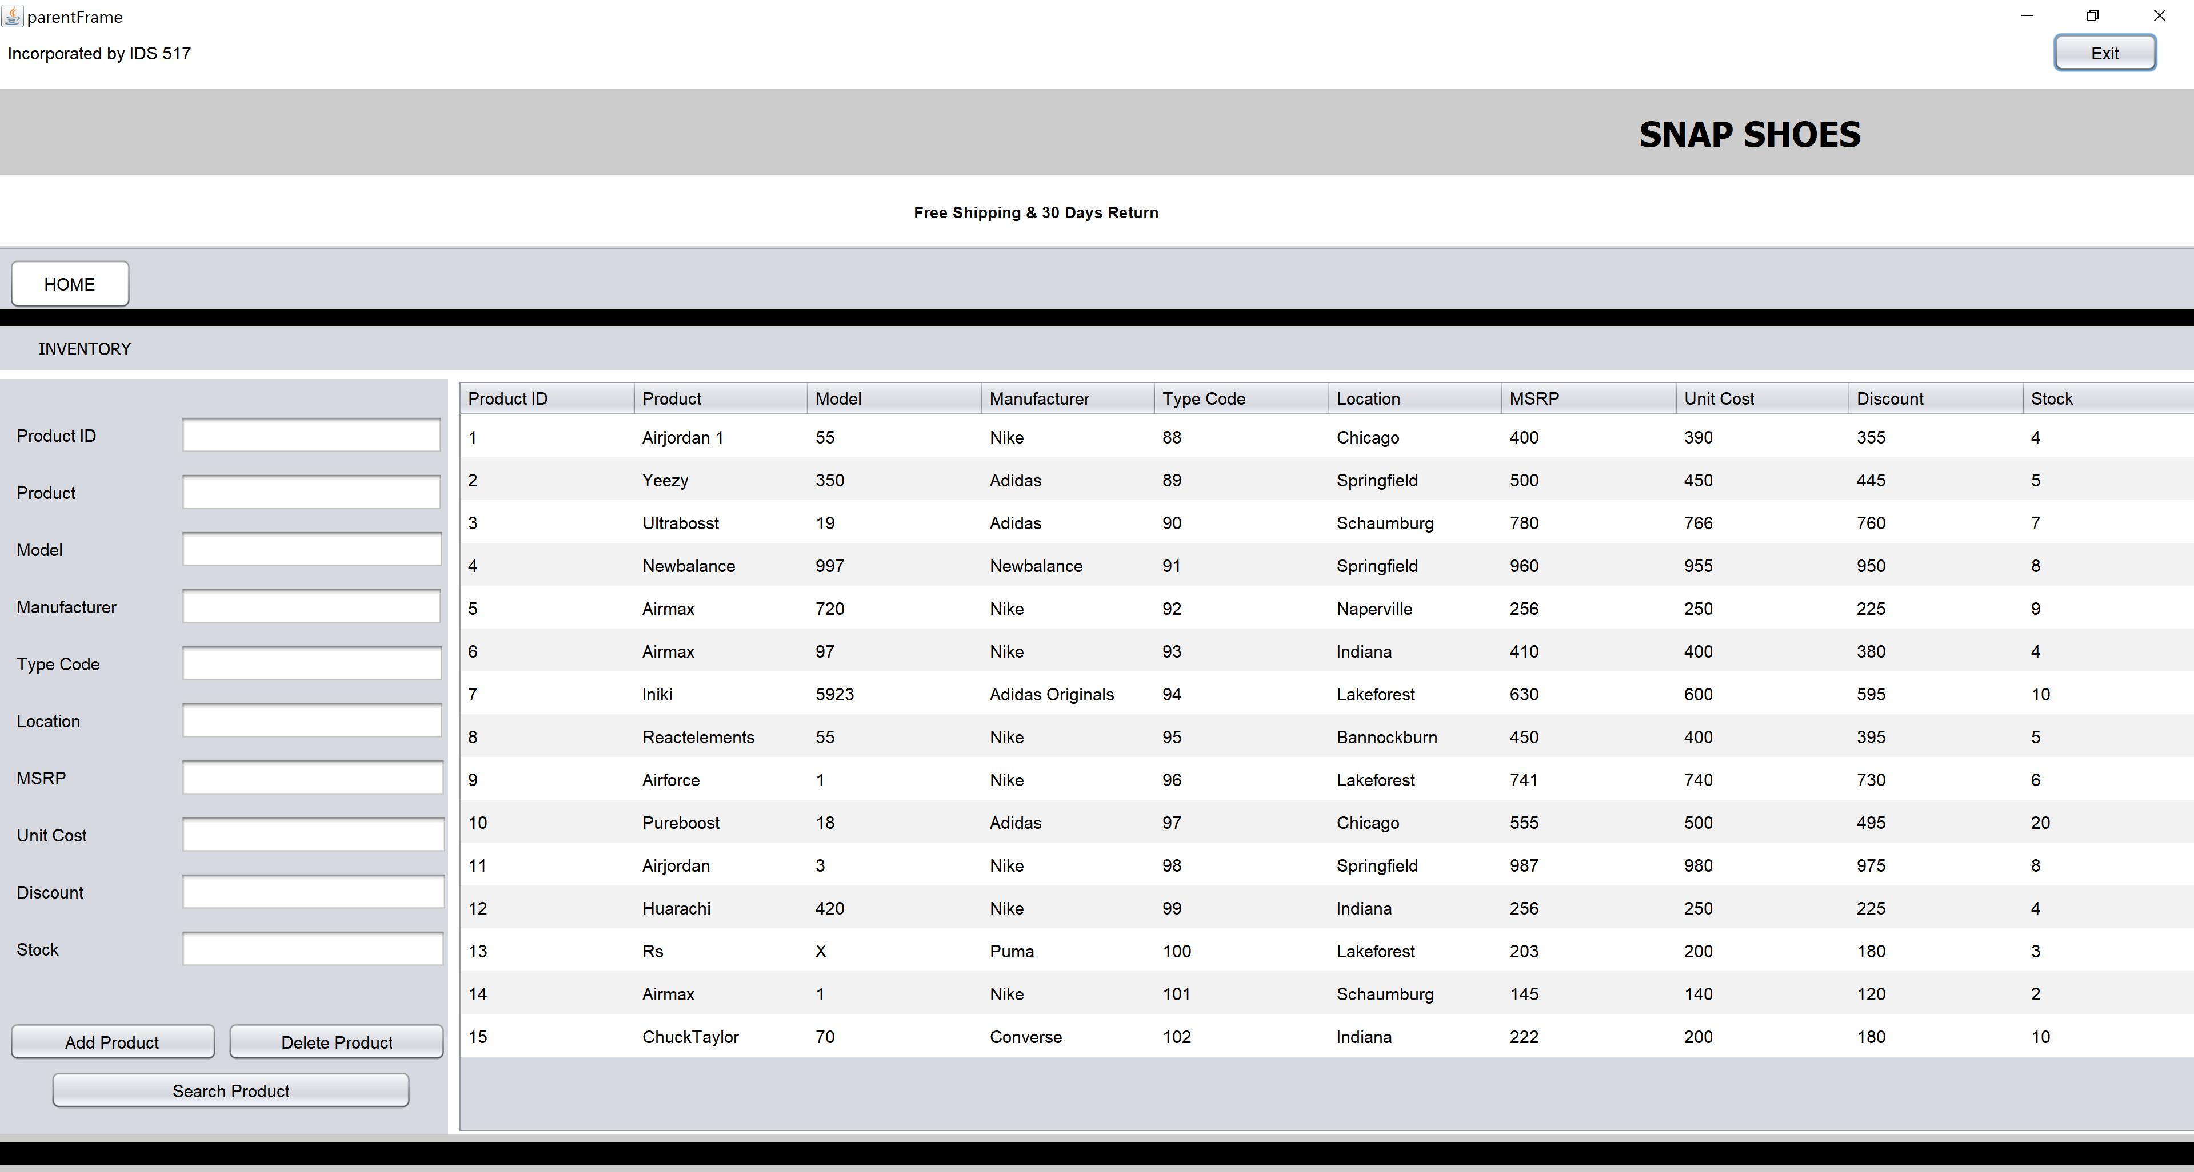

Search product -

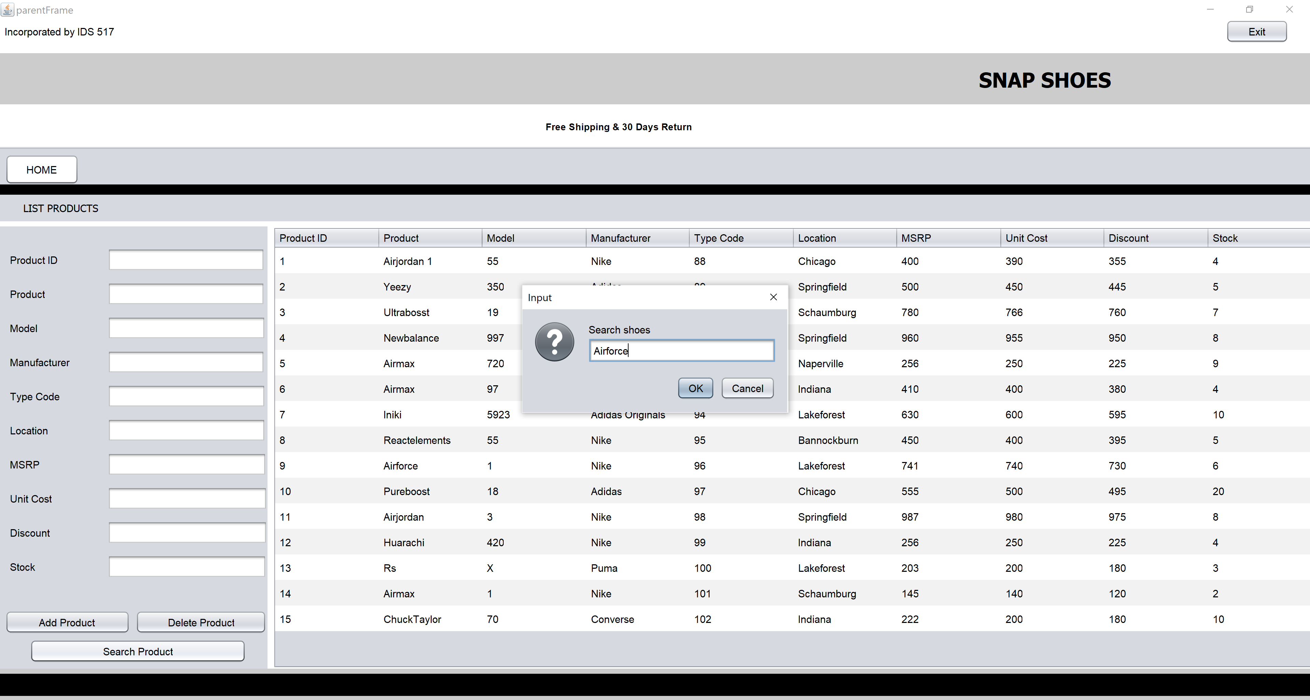

Add Product –

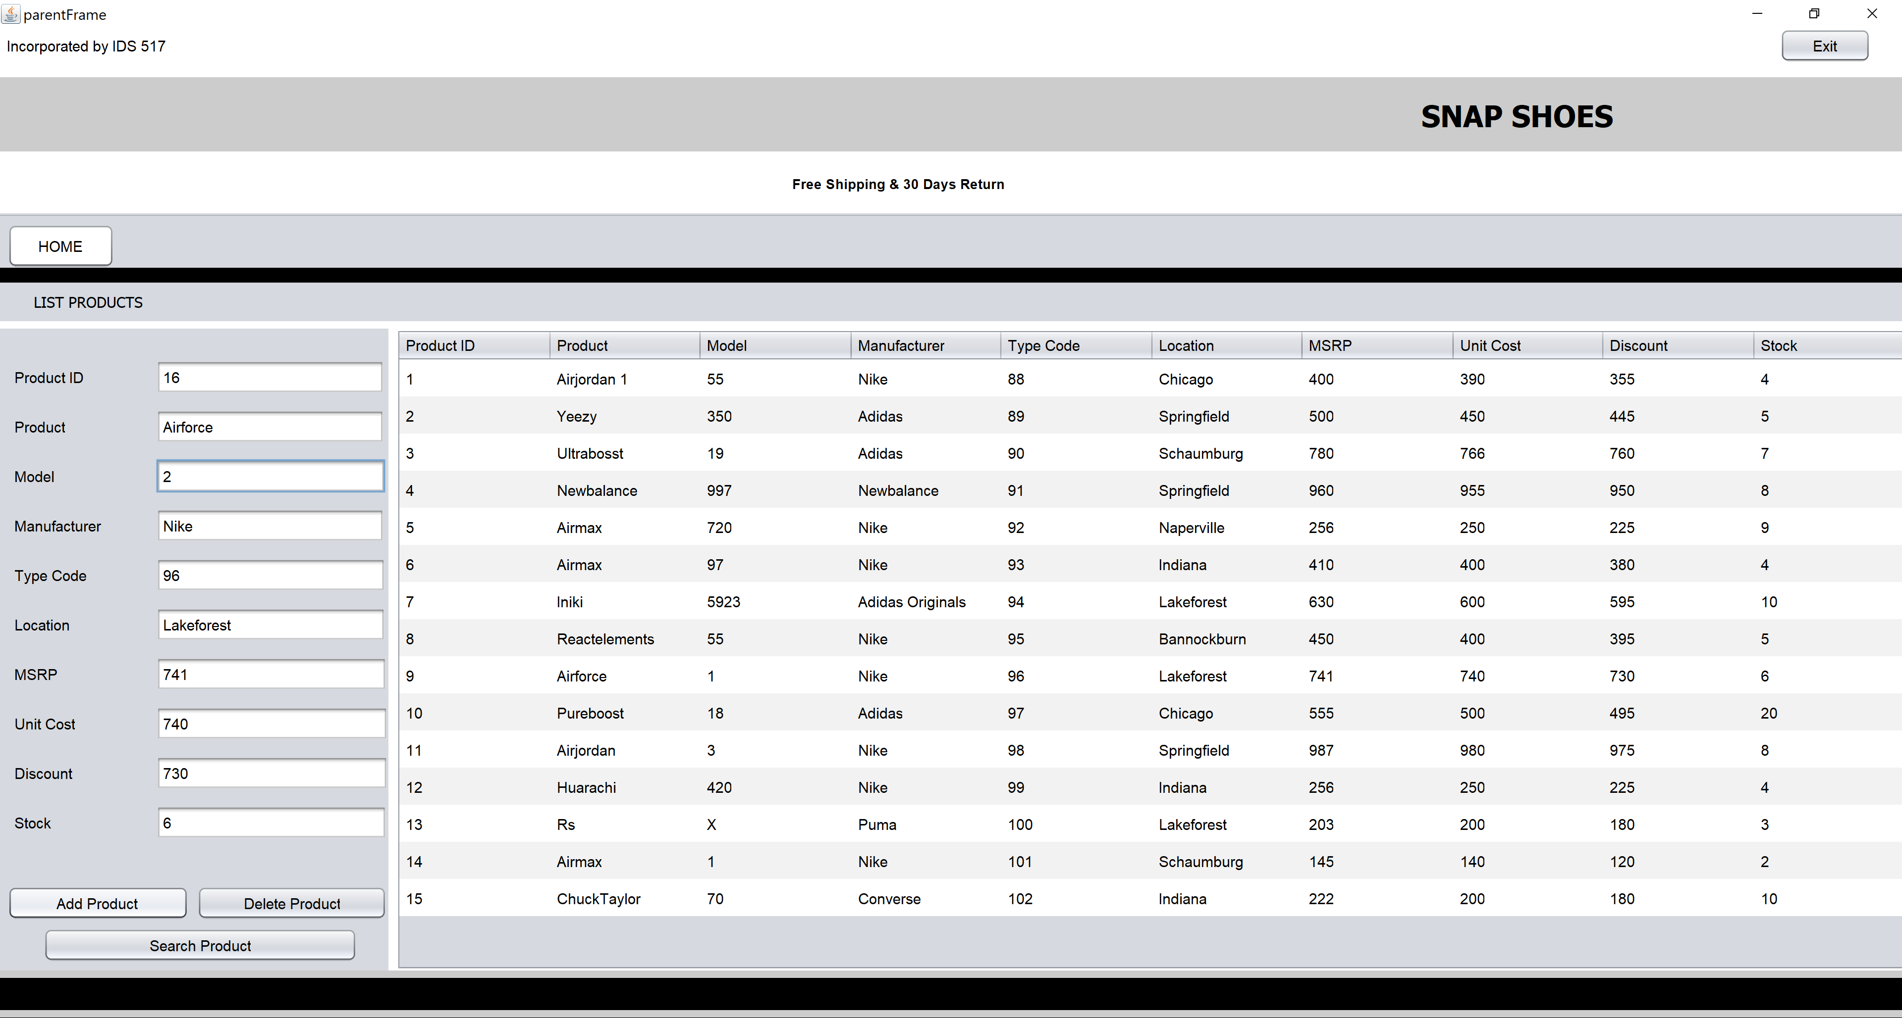

Delete Product–

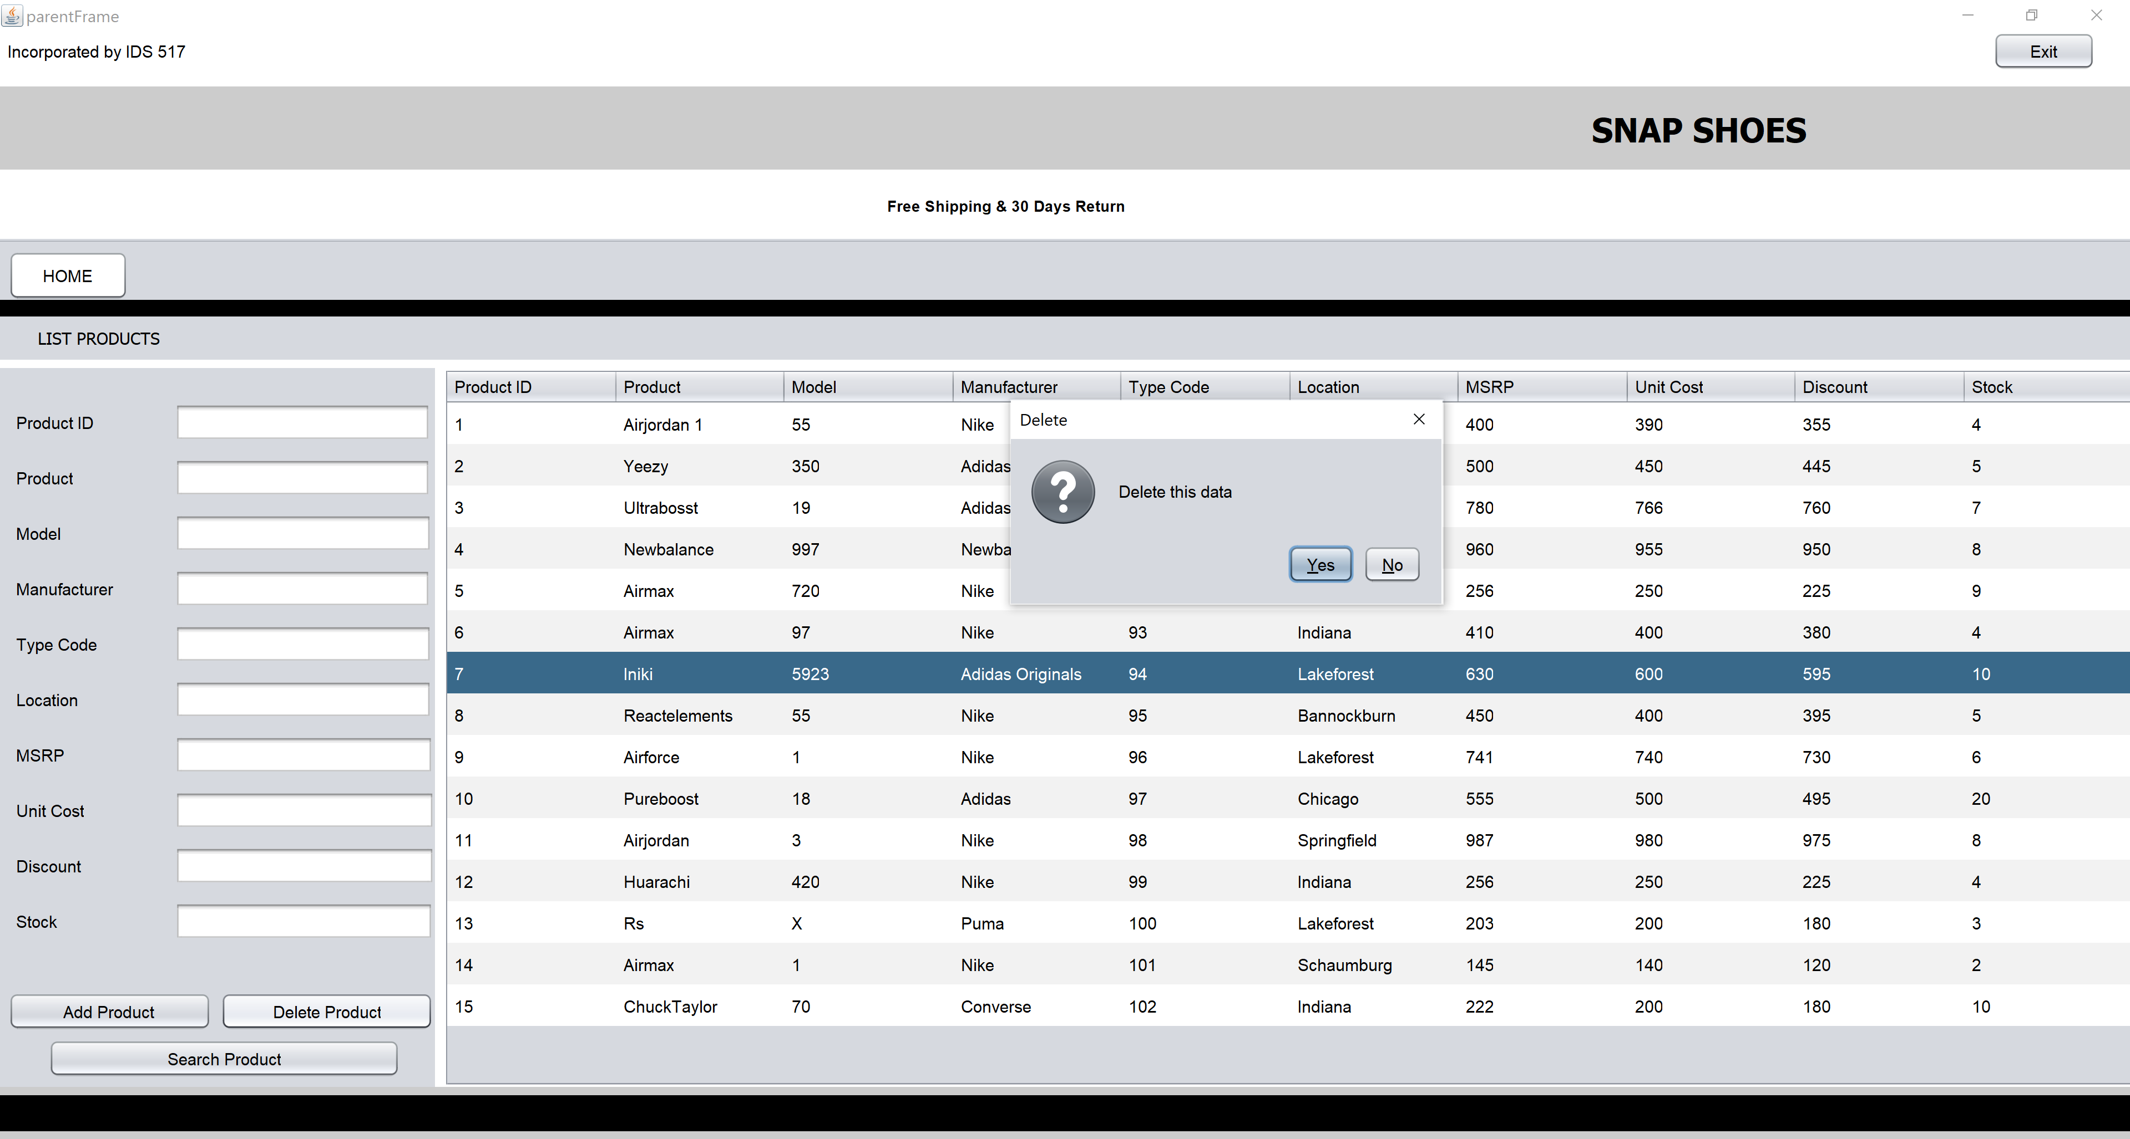

1. PRODUCT LIST: It maintains present as well as historic data of the products.

Customer -

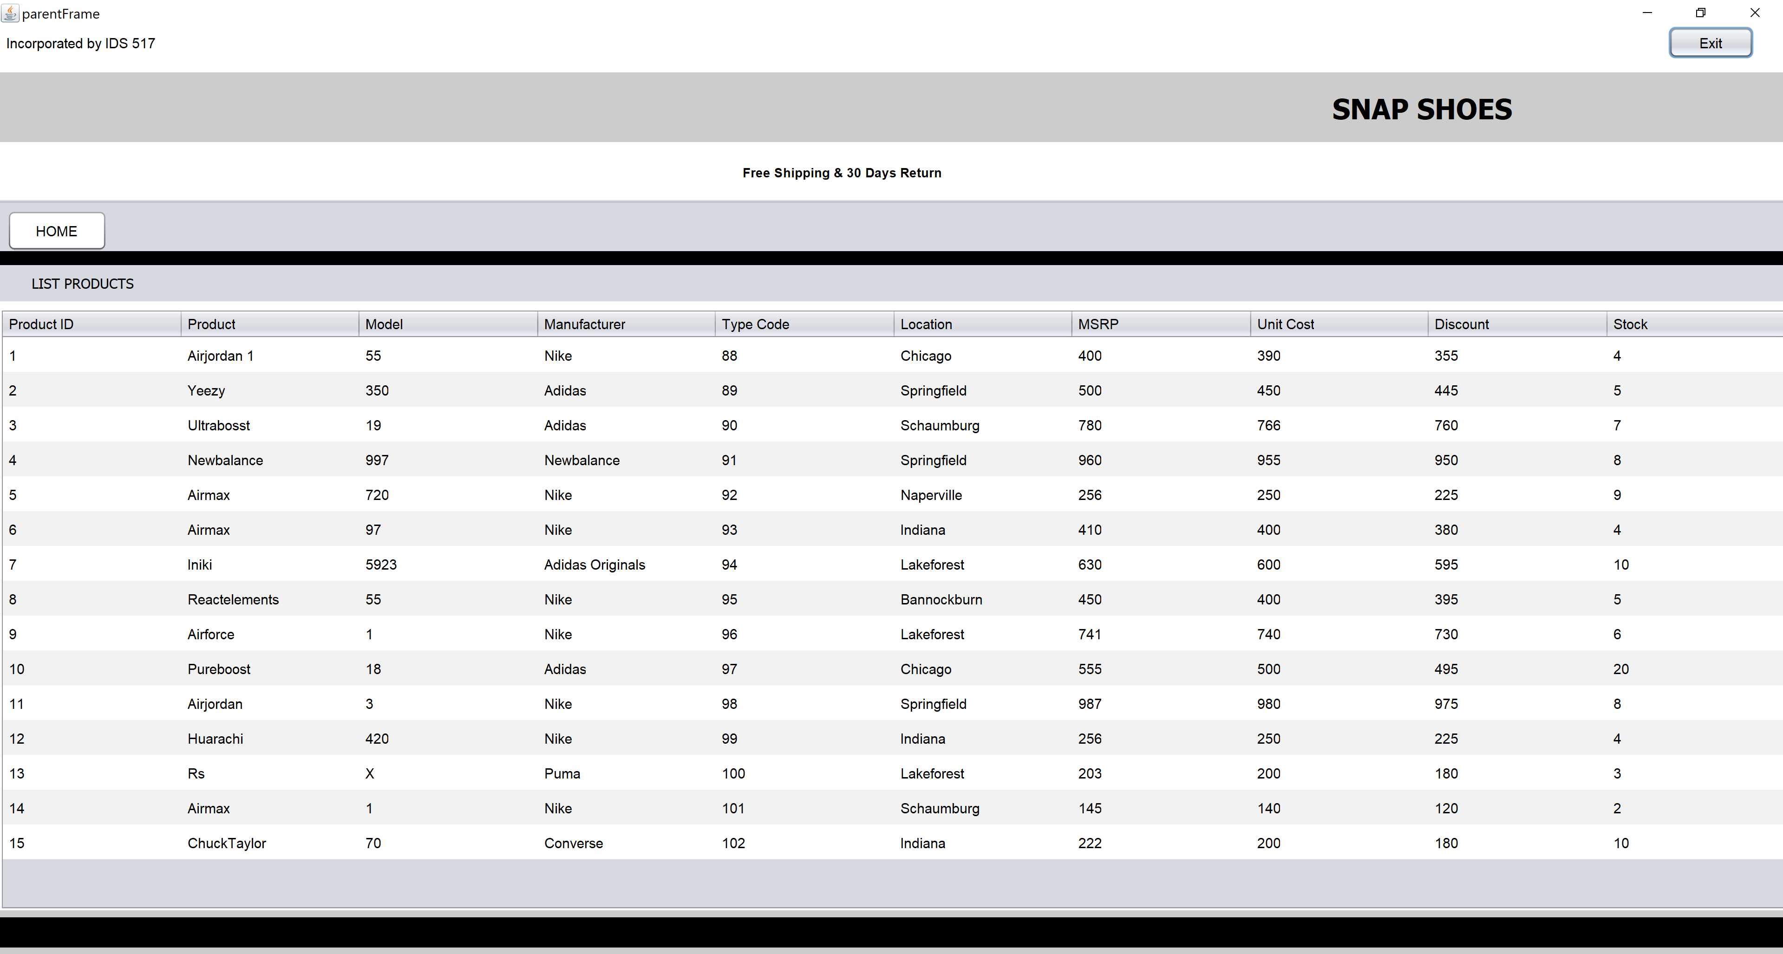

Admin –

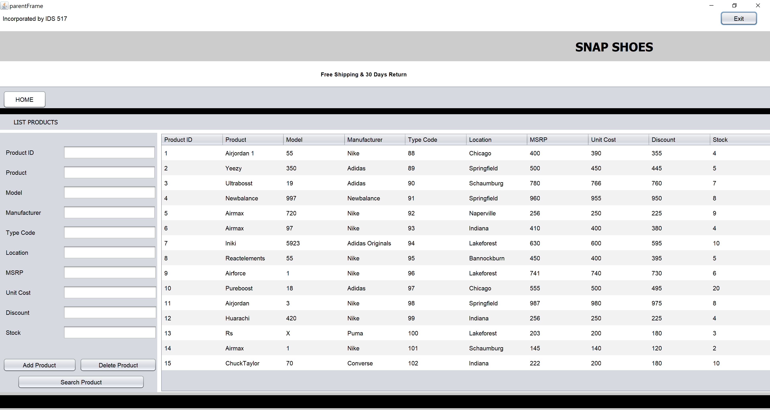

Search product -



Add Product –



Delete Product–



1. DISCOUNT AND OFFERS: Lists product details of all the ongoing offers and discounts available on site

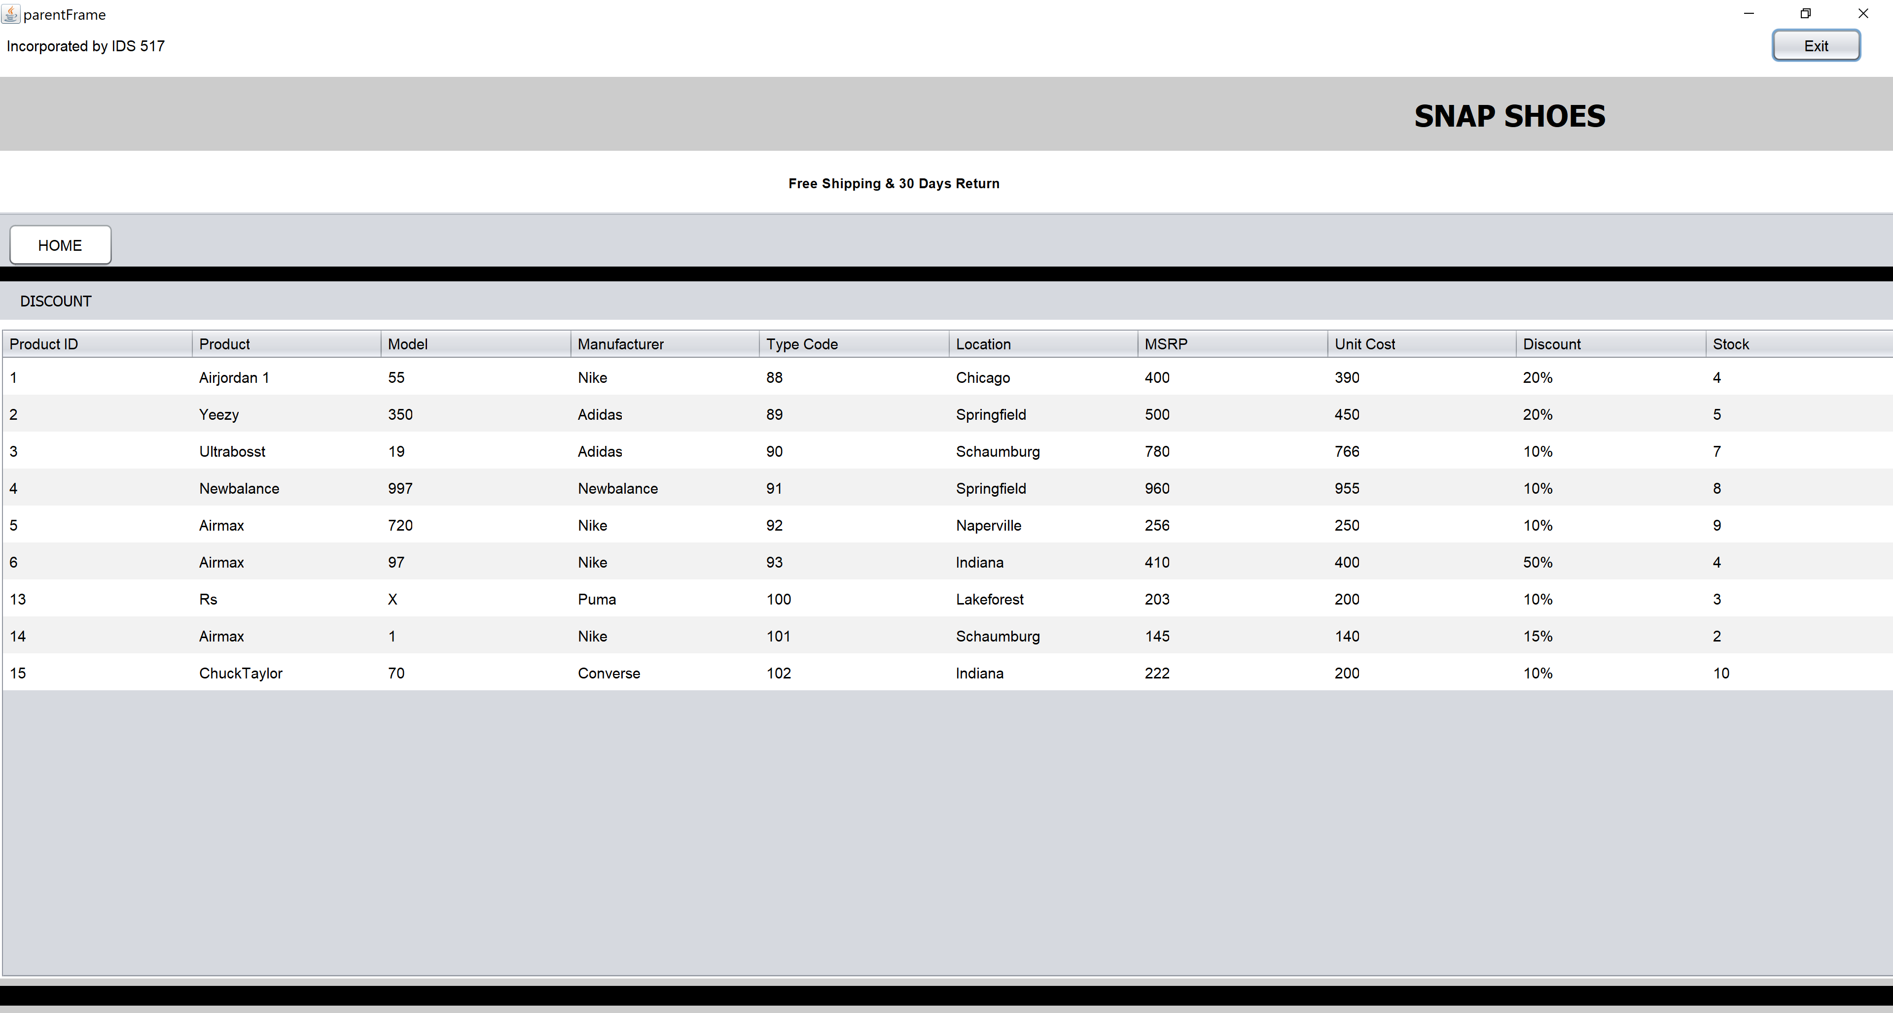

1. SALE UNDER 100$: List of products whose discounted price range is sorted and stored under 100$.

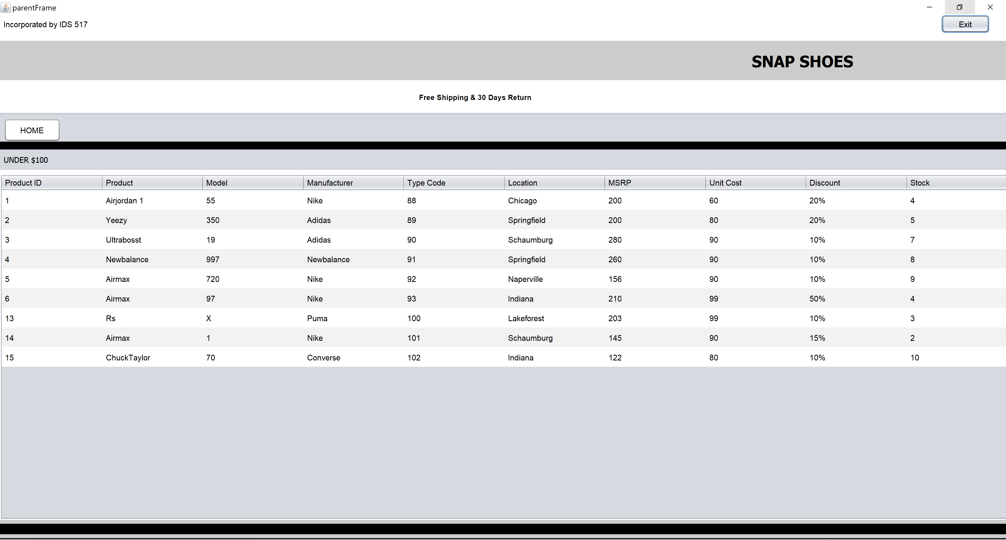

1. ADMIN LOGIN: Only the correct login details allow entry into the confidential page where products can be added, deleted or replaced according to availability.

1. CREATED BY:

1. EXIT: A command prompt opens to ask if we want to exit the system

